Quotation and Specification Sheet for Fence Semi Trailer
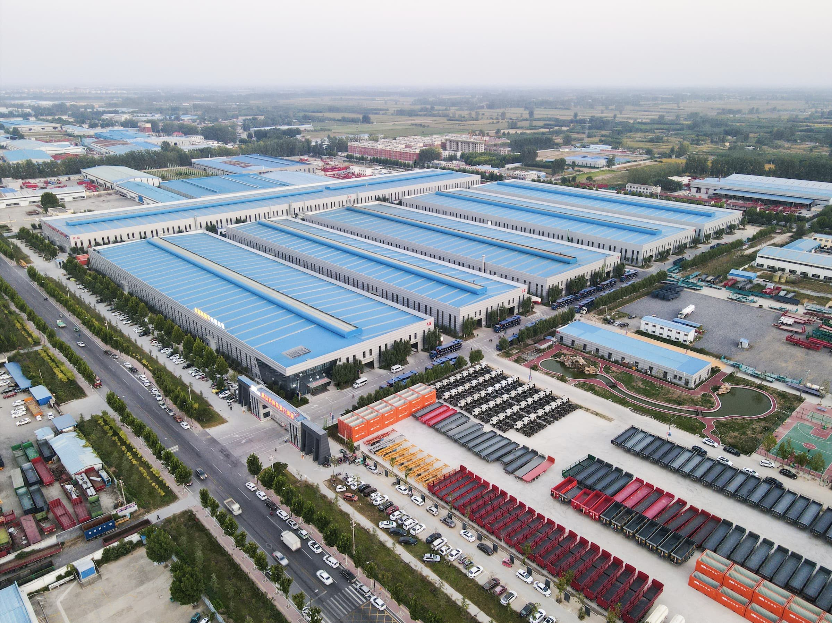

Quotation:

Description of goods | Quantity | Unit Price  (FOB Tianjin) | Unit Price  (CIF ) | Shipment
40FT Fence semi trailer | 1 unit | 11000USD/unit |  | 40FT/Bulk cargo ship

Terms & Conditions:
Spec.: | Please see the enclosed specification
Delivery: | 30 days after down payment received
Payment: | Down payment 30% by T/T within 5 days after order confirmation  Balance 70% by T/T before EXW.
Warranty: | 12 Months

Specification:

Type: |  | 40FT Fence semi trailer
Model: |  | SH9400CCYE
Dimension:
 | Length: | 12,400mm
 | Width: | 2,500mm
 | Drop Side Height: | 1800mm
 | Kingpin location: | 1,045mm from the front face of the front bolster
 | Axle spacer: | 7,200mm+1,310mm+1,310mm
(The above dimension will be adjusted according to the tractor specification.)

Weight:
 | Payload: | 40,000kg
 | Tare weight: | Approx. 8,000kg
 | G.V.W.R.: | Approx. 48,000kg
Frame & Structure:
 | Main beam: | Material Q345B. Fabricated “H” beam height 500mm, Top flange thickness 14mm, Middle web thickness 8mm, Bottom flange thickness 16mm
 | Side beam: | 16# channel steel
 | Platform: | 3mm thick chequer plate with supporting channel
 | Cross beam: | 10# channel steel
 | Kingpin: | 2” Kingpin, bolted in type
 | Welding standard: | All welding are to be done by qualified welder per applicable national standard
 | Painting: | Shot blast at Standard SA 2.5 prior to application of primer, water paint top coat. Total DFT not less than 80um
Running gear:
 | Suspension: | Standard mechanical suspension, 10 pcs leaf spring 13mmx90mm
 | Axle: | Open brand axles, 3pcs*13 ton capacity
 | Brake system: | Dual line pneumatic brake, with hose and connector
 | Brake chamber: | 4 units T30/30 spring brake chambers
 | Air tank: | 40L, 2 pcs, China
 | Emergency relay valve: | Wabco relay valve
 | Tire: | Linglong brand, 12R22.5, 12 pcs
 | Rim: | 9.00-22.5 steel disc wheel,10 holes ISO, 12 pcs
 | Landing gear: | 28T two speed telescopic manual landing gear

Electrical System:
 | Voltage: | 24 Volt
 | Receptacle: | 7 way socket standard, China
 | Front marker lamp: | White
 | Side marker lamp: | White & Red
 | Rear lamp: | Red
 | Turn signal lamp: | Amber
 | Reflector: | Per customer requirement
Accessories:
 | Mud guard: | Steel mud guard
 | Spare wheel carriers: | 1 sets
 | Tool box: | 1 pc
Note: All the details not mentioned above should comply with Chinese regulations. If any component or structure changed, the price shall be modified accordingly.
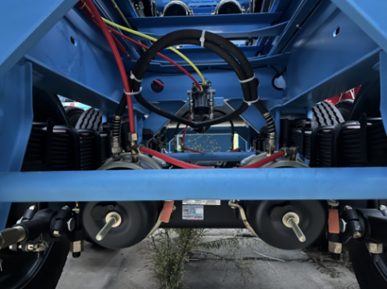
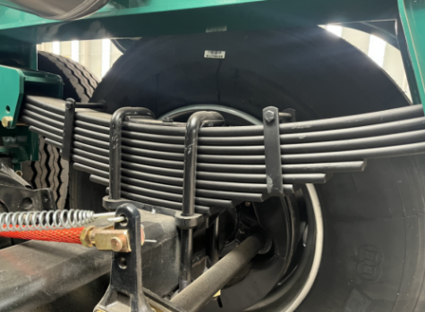
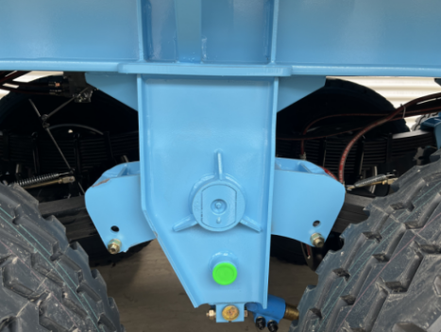

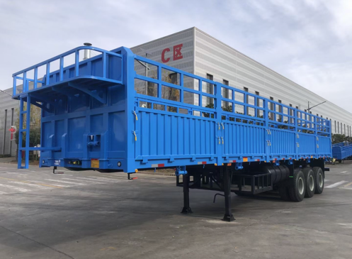
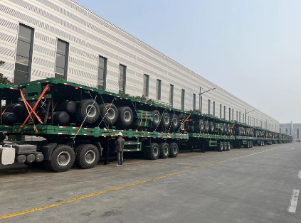
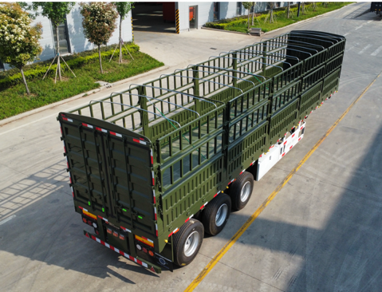

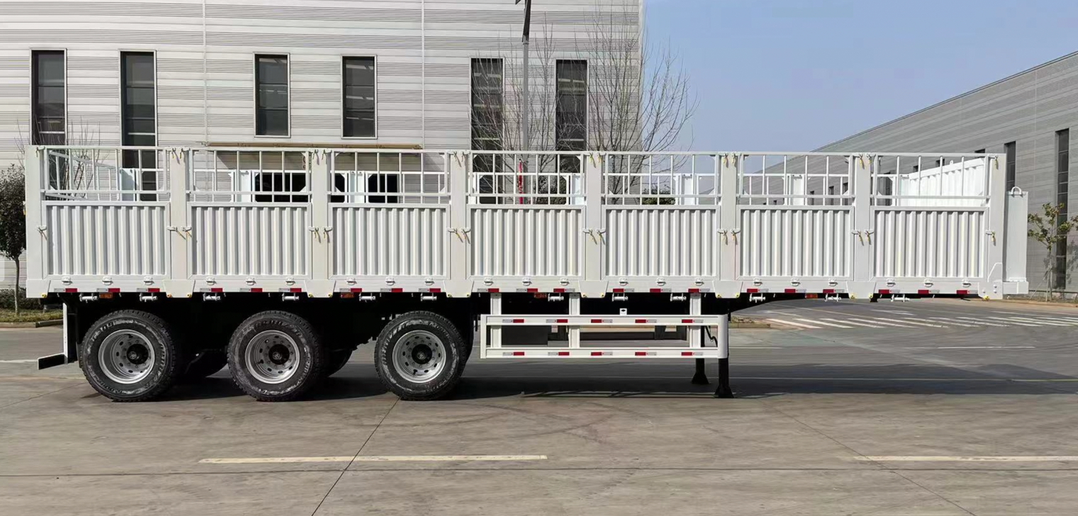

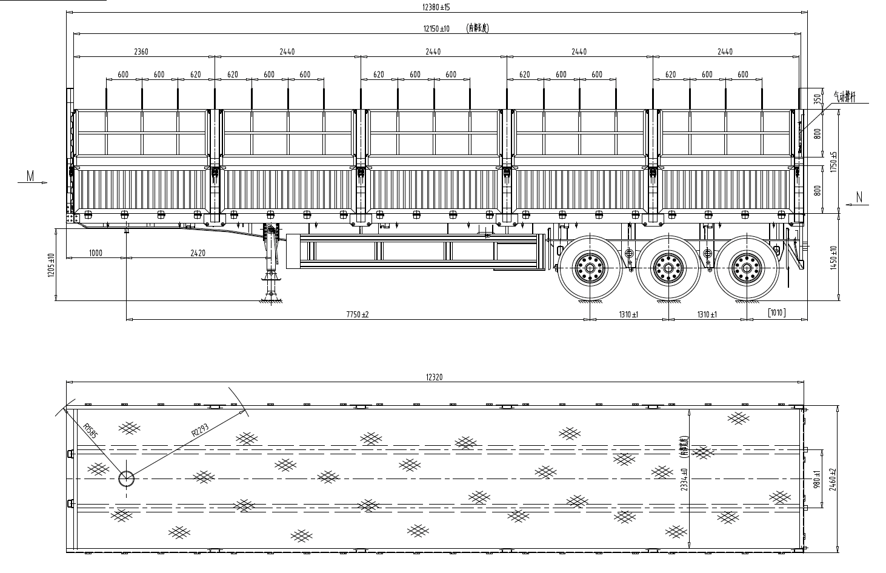

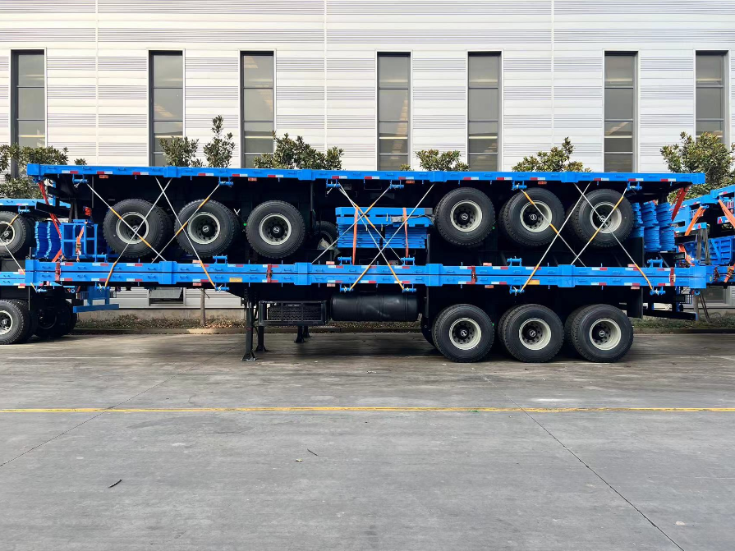

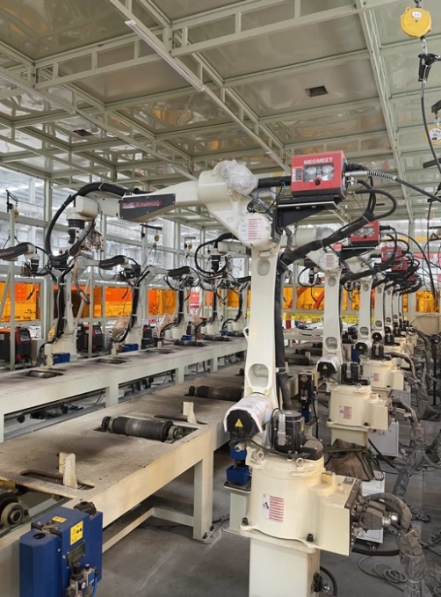
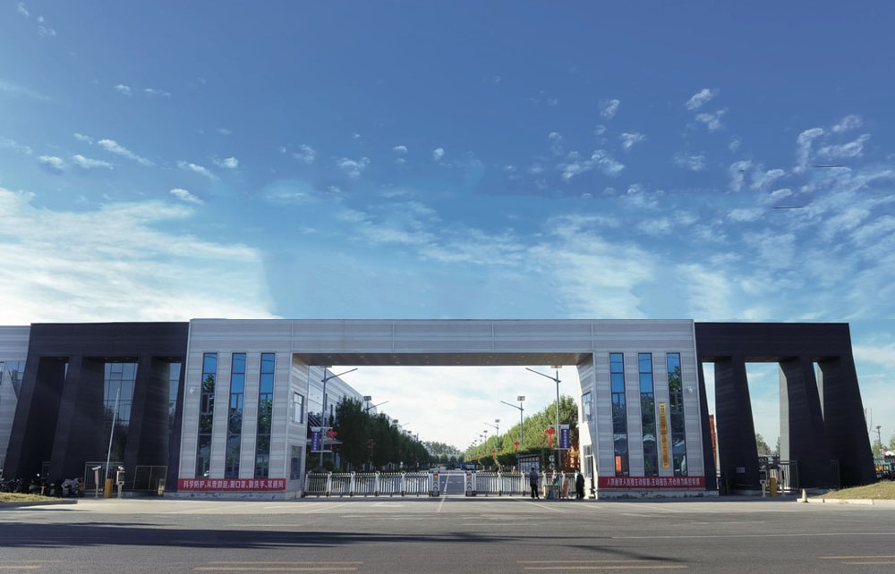
Our Factories

